Write a Prolog Program for STUDENT-TEACHER-SUB-CODE.

**AIM:**

To write a Prolog program that stores and retrieves the relationship between student, teacher, subject, and subject code.

**ALGORITHM:**

1. Start the program.
2. Define facts in the form student_teacher_sub(Student, Teacher, Subject, Code).
3. Load the program into Prolog.
4. Query using variables to retrieve required details.
5. Stop.

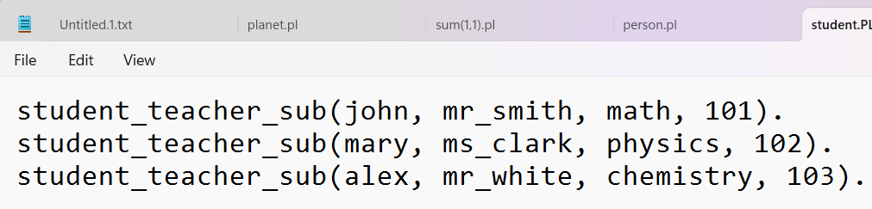

**OUTPUT:**

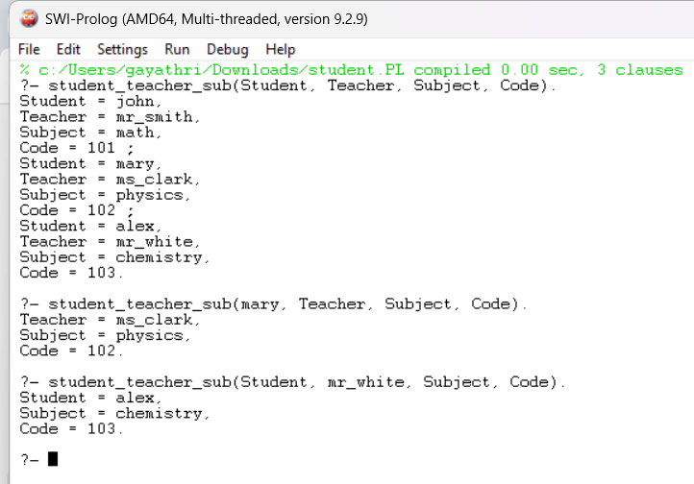

**RESULT:**

The program successfully stores and retrieves student–teacher–subject–code relationships from the knowledge base.